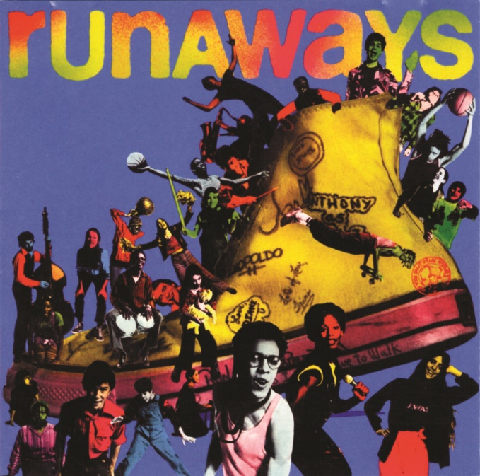
Victoria High School Presents
THE MUSICAL
Invite only performance
with talk back
“‘Runaways’ … is a group mentality, a gathering of injured souls who merge into one vital, hungry, desperate voice.” -NY Times

Thursday, February 27th
7:30pm
Vic High Auditorium

