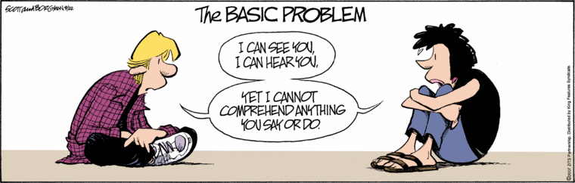
Interpersonal Communications 11
Mz. Hope
ghope@sd61.bc.ca
mzhopesclass.weebly.com

This course looks at the complex nature of interpersonal communications. Both theory and practical skills are covered. By using the experiential approach, you will develop a deeper awareness of yourself as a communicator, and in turn, increase your understanding of others and the effect of communication on relationships.
Units:
- Introduction
- Self Concept and Restitution
- The Communication Process
- Non-Verbal communication
- Listening and Empathy
- Digital Conversations
Evaluation:
- This course is highly experiential. To be successful in completing the goals of this course, attendance is an absolute necessity. Participation in all activities is mandatory.
- Reflective responses to theory and practical work in both verbal and written forms.
- Worksheets, quizzes, tests, research, group and individual work.
Classroom expectations:
- No cell phone use during class. You will be given a “text break” half way through class. Please respect our need to interact on a person to person level.
- Lates: please enter the classroom quietly and participate without causing disruption.
- Please come to class prepared with a binder and pen/pencil and an open mind.

