Communication Competence
What makes a good communicator?

- Communication Competence:
- T-P-S: What makes an effective communicator? Attempt to answer.

Scholars are still in disagreement! However, we can say that effective communication involves achieving one’s goals in a manner that, ideally, maintains or enhances the relationship in which it occurs.
- There is no IDEAL way to communicate: humour, hinting, straightforward- it all depends! Culture plays a big role.
- Competence is situational: what works in one situation, may not in another. Don’t say, “I’m a terrible communicator!” Instead, try “I didn’t handle this particular situation well.”
- Competence is relational: As with different situations, different relationships dictate what will be effective and what won’t.

- What does a competent communicator look like?
- A wide range of behaviours (situational and relational).
- Ability to choose appropriate behavior.
- Skill at performing the behavior.

Exercise: How do you rate your communication competence? Think of a relationship or situation in which you demonstrate each of the following:
- Beginning awareness: You have realized there must be a better way and you have begun the journey; you are just not sure what to do yet!
- Awkwardness: Your initial attempts at communicating in a new way will feel awkward! This doesn’t mean there is something wrong with it. Just like learning anything new, like riding a bike: it’ll feel weird at first!
- Consciously skilled: Were you willing to keep working at it to overcome the awkwardness? If you were, you would have reached a level of skillfulness: you can handle yourself well, but you may still need to think about what you are doing. In fact, this is characterized by a LOT of thinking and planning.
- Integration: You are now able to perform well in this arena without thinking about it too much.
Competence cont…
- Cognitive complexity: considering the issue from a variety of angles.
- Self-Monitoring: the process of paying close attention to one’s behavior and using these observations to shape the way one continues to behave. Ie. “I’m making a fool out of myself,” or, “I’d better speak up now.”
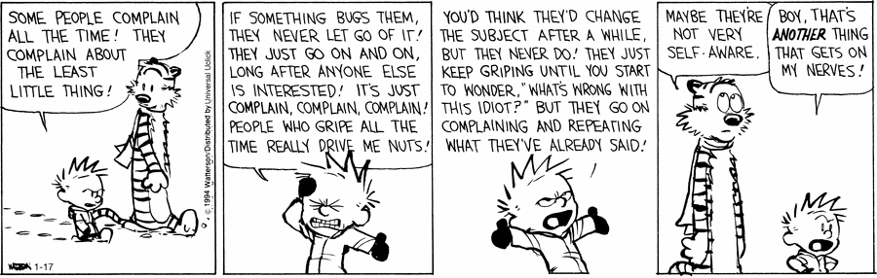

- Commitment: People who seem to care about the relationship communicate better than those who don’t. They show commitment to both the person and the message.

Homework Assignment: Check your competence worksheet (attached).

Key terms (review for movie essay assignment):
communication communication competence decode
content message encode environments feedback
impersonal communication interpersonal communication linear model
transactional model noise (external, physiological, psychological)
relational message self-monitoring needs : physical, identity, social, practical
instrumental goals behavior (in relation to needs and communication)
Principles misconceptions metacommunication

Check your competence!
Interpersonal Communications Homework Assignment

Other people, especially significant others, are often the best judges of your communication competence. They can also offer useful information on how to improve your communication skill.
- Choose a parent/guardian or another significant adult in your life with whom you communicate often. Name your partner. /1
- Identify five situations in which you communicate. For example, handling conflicts, getting work done, choosing free time, issues with friends, expressing feelings, phone use, etc. /5
- For each of the situations, have the adult rate your competence by answering the following questions. You may have to review your notes with this person and teach them about what you have been learning in class. Take notes on what their answers are. /20
- Do I have a wide repertoire of response styles in this situation or do I always respond the same way?
- Am I able to choose the most effective way of behaving for the situation at hand?
- Am I skillful at performing appropriate behaviours in order to communicate effectively? Note: knowing how you want to behave isn’t the same as being able to do it).
- Do I communicate in ways that leaves the other person satisfied?
- After reviewing the answers to these questions, identify the areas in which your communication is most competent. /1
- Choose one situation in which you would like to improve your communication and with the help of your partner, /4
- Determine whether your repertoire of behaviours needs to be expanded.
- Identify the ways in which you need to communicate more effectively.
- Develop ways to monitor your behavior in the key situation to get feedback for on your effectiveness.

